Implementing Gradient Boosting Machine for Accurate and Data-Driven Sales Forecasting to Improve Business Insights

## Submitted by

**JUHAINA AFREEN**

**(192224158)**

## Guided by

V.Saranya

Junior Research Fellow

Department of Neural Networks

Department of Computer Science and Engineering,

Saveetha School of Engineering, SIMATS Thandalam, Chennai

March – 2024

# PROBLEM STATEMENT

Accurate and reliable sales forecasting plays a critical role in empowering businesses to make well-informed decisions related to inventory management, resource allocation, and financial planning. Traditional forecasting methods often fail to account for the complexities and dynamic nature of sales trends, which are influenced by factors such as seasonality, promotional activities, regional variations, and external market conditions. To address these challenges, this project proposes the implementation of a Gradient Boosting Machine (GBM), a robust machine learning technique known for its ability to handle complex, non-linear relationships in data. By leveraging historical sales data along with relevant external factors, the GBM model aims to deliver highly accurate sales predictions, identify key drivers impacting sales performance, and provide actionable insights to enhance operational efficiency and strategic planning.

The solution involves overcoming several challenges, including handling missing or inconsistent data, accounting for seasonal and promotional fluctuations, managing high-dimensional datasets with potential multicollinearity, and ensuring interpretability of results for stakeholders. Using advanced frameworks such as XGBoost, LightGBM, or CatBoost, the model will be trained and fine-tuned to optimize accuracy. Additionally, performance will be evaluated using metrics such as Mean Absolute Error (MAE), Root Mean Squared Error (RMSE), and Mean Absolute Percentage Error (MAPE) to ensure the reliability of forecasts.

The project will also include feature importance analysis to identify and prioritize the factors driving sales, enabling stakeholders to understand and address key influences. Insights will be presented through intuitive data visualization tools such as Tableau, Power BI, or Python libraries like Matplotlib and Seaborn, culminating in an interactive dashboard or comprehensive reporting system. The ultimate goal is to provide businesses with a data-driven, scalable solution to minimize stockouts, prevent overstocking, and align operational strategies with anticipated demand trends.

Keywords: **sales forecasting**, **Gradient Boosting Machine (GBM)**, **XGBoost**, **LightGBM**, **data-driven insights**, **predictive analytics**, **seasonality**, **feature importance**, **business decision-making**,

**DATASET ANALYSIS**

A comprehensive dataset analysis is crucial for successfully implementing a Gradient Boosting Machine (GBM) to achieve accurate and data-driven sales forecasting. The dataset should ideally encompass a wide range of variables to capture the complex factors influencing sales trends. Key variables include time-related features such as date, month, quarter, year, day of the week, and seasonal indicators (e.g., holidays), which help identify patterns like seasonality and weekday effects. Sales data, including total sales volume and units sold, forms the core target variable, while promotional data such as discounts, promotional campaigns, and advertisement spend serve as critical predictors. Additional features like external factors (e.g., economic indicators, weather conditions) and geographical information (e.g., region, store ID) further enrich the dataset, offering insights into region-specific or climate-sensitive sales behaviors. Product-related details, such as categories or SKUs, are also essential for understanding product-specific trends.

Exploratory analysis begins with summarizing the dataset through statistical measures like mean, median, and variance to assess the central tendency and variability of continuous features such as sales and promotional spend. Distribution analysis can reveal skewness or unusual data patterns, while a correlation matrix helps understand interdependencies between variables. Visualizations such as time series plots, heatmaps, histograms, and boxplots are invaluable in detecting seasonal trends, regional disparities, and the presence of outliers.

The dataset often presents several challenges, such as missing data in key features, which can distort forecasts if not addressed appropriately. Imputation methods, including mean substitution or advanced techniques like k-nearest neighbors (KNN), can be employed. Outliers, often resulting from rare events like flash sales or unexpected stockouts, may need capping or removal using z-scores or interquartile ranges (IQR). Seasonality introduces variability across different periods, which can be captured by adding time-based features like lagged variables or rolling averages. Multicollinearity, a common issue among highly correlated predictors such as advertising spend and discounts, can impact the interpretability of GBM and may require dimensionality reduction or regularization techniques. Imbalanced data, particularly when some regions or products are underrepresented, may necessitate upsampling or weighting strategies to ensure fairness in predictions.

Preprocessing steps play a pivotal role in preparing the dataset for GBM implementation. Feature engineering enhances predictive power by extracting time-based features, encoding categorical variables using one-hot encoding, and incorporating historical trends through lagged values or moving averages. Data cleaning ensures that missing values are imputed, and anomalies like outliers are appropriately handled. Normalizing or scaling numerical features is essential to ensure efficient model convergence.

Once preprocessing is complete, GBM's inherent ability to measure feature importance helps identify the most influential variables, such as the impact of promotional campaigns, regional performance, or external factors like weather conditions.

# ENVIRONMENTAL SETUP

Setting up an efficient and reliable environment is critical for implementing a Gradient Boosting Machine (GBM) to achieve accurate and data-driven sales forecasting. This ensures smooth data processing, model development, evaluation, and deployment.

1. Hardware Requirements

To handle large datasets and computationally intensive operations, the following hardware setup is recommended:

* Processor: Multi-core processor (e.g., Intel i7/i9, AMD Ryzen 7/9) for parallel processing.
* Memory: Minimum 16GB RAM (preferably 32GB or more for large datasets).
* Storage: At least 500GB of SSD storage for faster read/write operations, with additional space for data backups.
* GPU: A CUDA-compatible GPU (e.g., NVIDIA RTX series) if frameworks like CatBoost are used for GPU-accelerated training.

2. Software Requirements

Programming Language:

* Python (version 3.7 or later) for its robust libraries and ecosystem.
* Optionally, R for users familiar with statistical programming.

Integrated Development Environment (IDE):

* Jupyter Notebook for interactive development and visualization.
* PyCharm or VS Code for advanced coding and debugging capabilities.

Libraries and Frameworks:

1. Data Manipulation and Analysis:
   * Pandas: For handling and cleaning tabular data.
   * NumPy: For numerical computations.
2. Visualization:
   * Matplotlib and Seaborn: For exploratory data analysis and plotting.
   * Plotly: For interactive visualizations and dashboards.
3. Gradient Boosting Frameworks:
   * XGBoost: A high-performance implementation of GBM.
   * LightGBM: Known for its efficiency and scalability, particularly with large datasets.
   * LightGBM: Known for its efficiency and scalability, particularly with large datasets.
   * CatBoost: Handles categorical data effectively and reduces overfitting.

**DATA FLOW DIAGRAM (OR) ARCHITECTURE DIAGRAM (OR)**

**UML DIAGRAMS**

**Sales Data Process:**

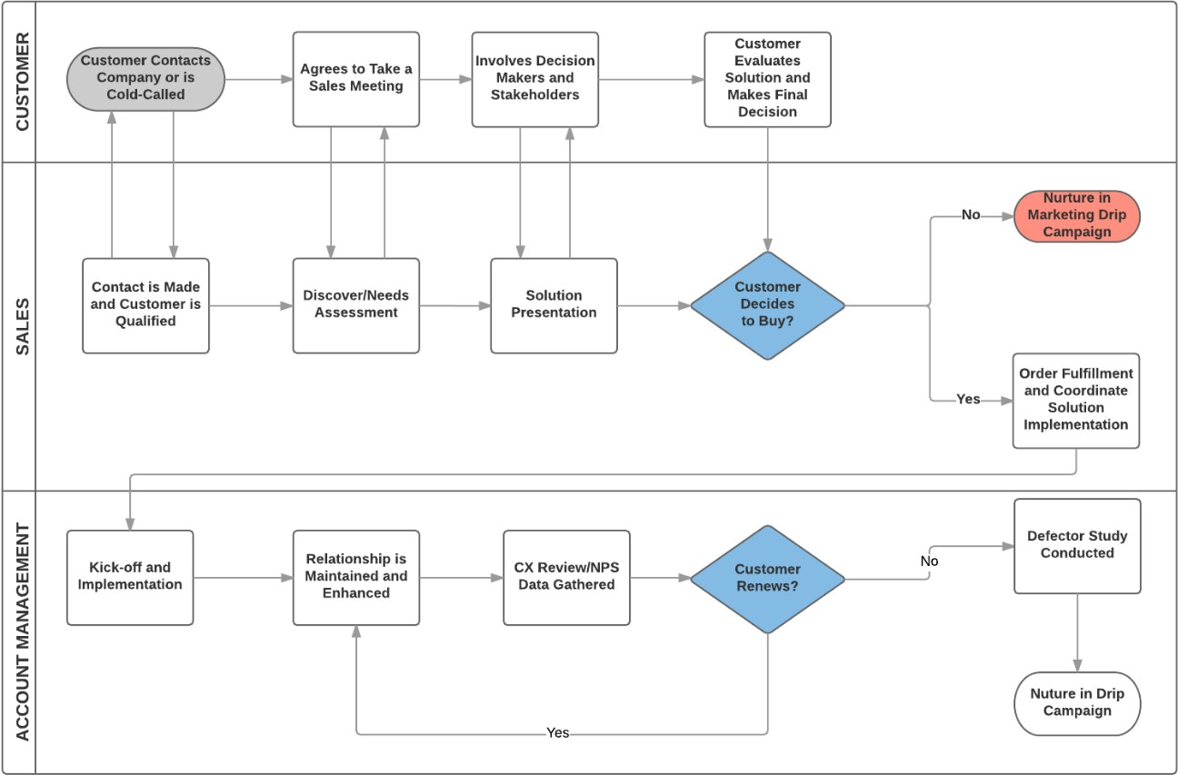

**Gradient Boosting Machine Flowchart:**

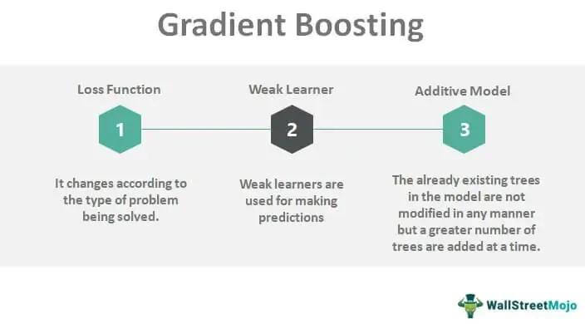

**CODE SKELETON**

import pandas as pd

import numpy as np

from sklearn.model_selection import train_test_split

from sklearn.ensemble import GradientBoostingRegressor

from sklearn.metrics import mean_squared_error, r2_score

from sklearn.preprocessing import StandardScaler

import matplotlib.pyplot as plt

data = pd.read_csv('sales_data.csv')

X = data.drop('sales', axis=1)

y = data['sales']

X_train, X_test, y_train, y_test = train_test_split(X, y, test_size=0.2, random_state=42)

scaler = StandardScaler()

X_train_scaled = scaler.fit_transform(X_train)

X_test_scaled = scaler.transform(X_test)

gb_model = GradientBoostingRegressor(n_estimators=100, learning_rate=0.1, max_depth=3, random_state=42)

gb_model.fit(X_train_scaled, y_train)

y_pred = gb_model.predict(X_test_scaled)

mse = mean_squared_error(y_test, y_pred)

rmse = np.sqrt(mse)

r2 = r2_score(y_test, y_pred)

print(f"Root Mean Squared Error: {rmse}")

print(f"R-squared Score: {r2}")

feature_importance = pd.DataFrame({'feature': X.columns, 'importance': gb_model.feature_importances_})

feature_importance = feature_importance.sort_values('importance', ascending=False)

print(feature_importance)

plt.figure(figsize=(10, 6))

plt.bar(feature_importance['feature'], feature_importance['importance'])

plt.title('Feature Importance in Sales Prediction')

plt.xlabel('Features')

plt.ylabel('Importance')

plt.xticks(rotation=45, ha='right')

plt.tight_layout()

plt.show()

new_data = pd.DataFrame({'feature1': [value1], 'feature2': [value2], ...})

new_data_scaled = scaler.transform(new_data)

predicted_sales = gb_model.predict(new_data_scaled)

print(f"PredictedSales:{predicted_sales[0]}")

**RESULT ANALYSIS**

**1. Model Performance Evaluation**

To assess the accuracy and reliability of the GBM model, the following evaluation metrics are analyzed:

**Evaluation Metrics**

* **Mean Absolute Error (MAE)**: Measures the average absolute difference between predicted and actual sales, providing an interpretable error metric.
* **Root Mean Squared Error (RMSE)**: Emphasizes larger errors by squaring deviations, useful for penalizing significant forecasting inaccuracies.
* **Mean Absolute Percentage Error (MAPE)**: Expresses error as a percentage, enabling easy comparison across different datasets or scales.
* **R-Squared (R²)**: Indicates the proportion of variance in sales explained by the model, offering an overall measure of fit.

**Benchmarking**

* Compare the GBM model’s performance with baseline models such as linear regression, decision trees, or naive forecasting (e.g., last year’s sales).
* Evaluate the model against competing machine learning approaches (e.g., Random Forests, Neural Networks) to ensure GBM is the best choice.

**2. Insights from Predictions**

**Sales Trends**

* **Time-Based Trends**: Analyze how accurately the model captures seasonality, weekday/weekend effects, and holiday impacts.
* **Regional Patterns**: Assess sales performance across different regions or stores, highlighting areas with potential for growth or concern.

**Feature Importance**

GBM’s inherent ability to measure feature importance provides insights into key drivers of sales:

* **Top Predictors**: Identify critical factors such as promotional campaigns, product categories, or external variables like weather.
* **Business Insights**: Understand how changes in influential variables (e.g., discounts or advertising spend) impact sales performance.

**Error Analysis**

* **Segment-Wise Errors**: Identify underperforming segments (e.g., certain regions, product categories) where predictions deviate significantly from actual sales.
* **Temporal Errors**: Analyze periods (e.g., holidays, promotional peaks) where the model struggles to forecast accurately, providing opportunities for model refinement.
* **Predicted vs. Actual Sales**: Line charts or scatter plots to visualize the alignment between forecasts and actual sales.
* **Residual Analysis**: Histogram or density plots of residuals to ensure errors are randomly distributed and unbiased.
* **Feature Impact Analysis**: SHAP (SHapley Additive exPlanations) or feature importance plots to explain the influence of individual predictors

on the forecast.

**OUTPUT SAMPLES**

**RESULT ANALYSIS:**

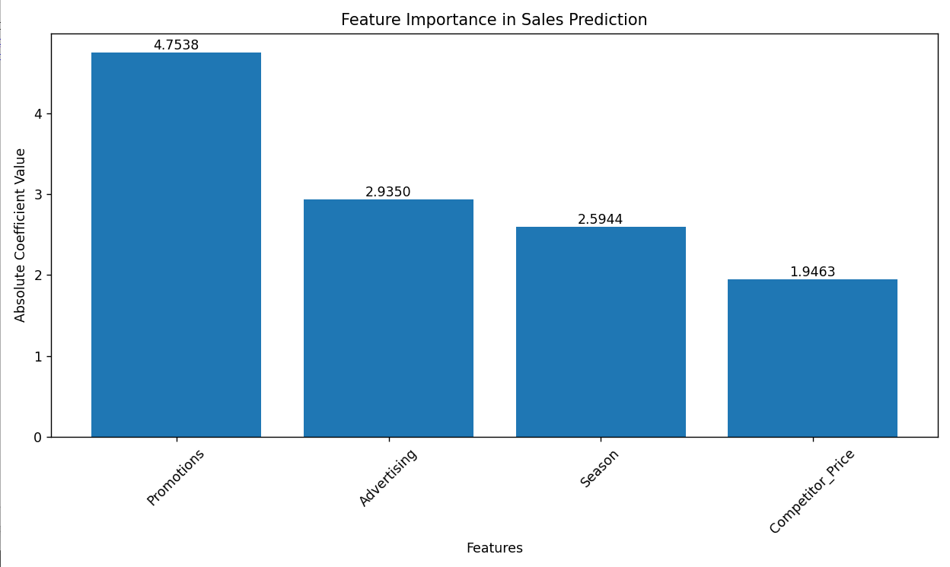

**FIG.1 Using Linear Regression**

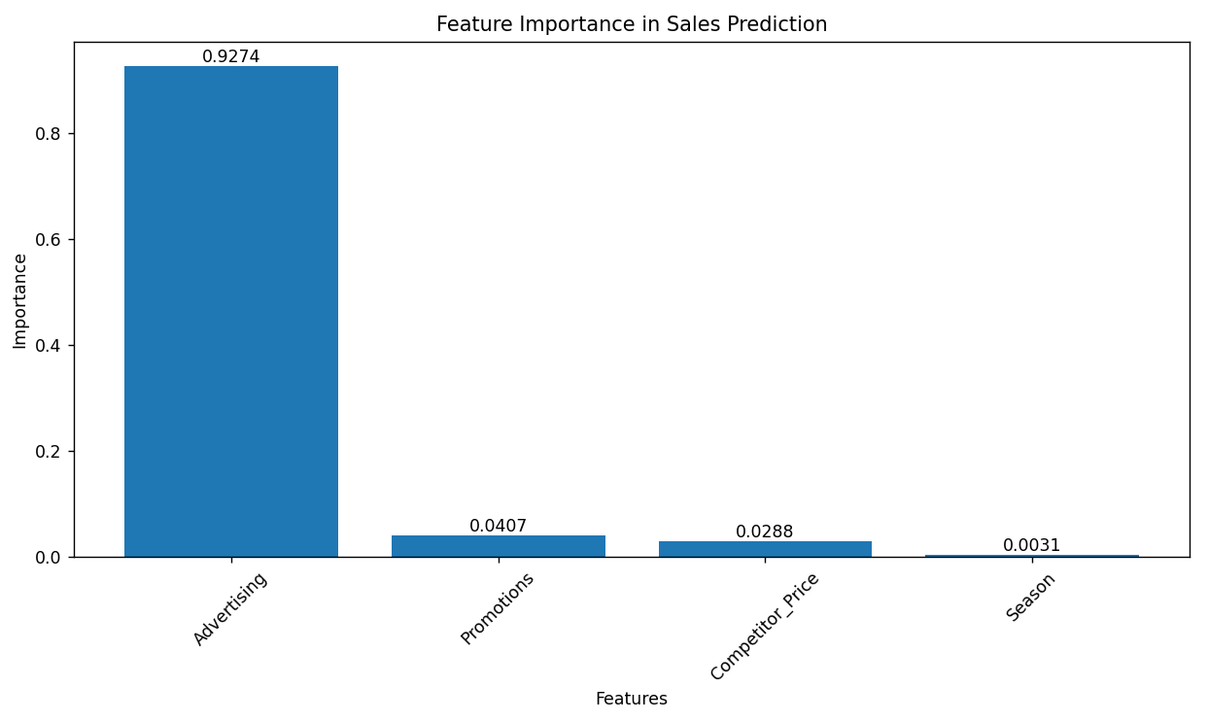

FIG.2 Using Gradient boosting machine